Downloading DHS Datasets
Template instructions which can be included in README files that describe re-using DHS data.
Authors: Benjamin Daniels, Jishnu Das, Quy-Toan Do and Samikshya Siwakoti
Go to the DHS program website at thedhsprogram.com and register as a new user for data access
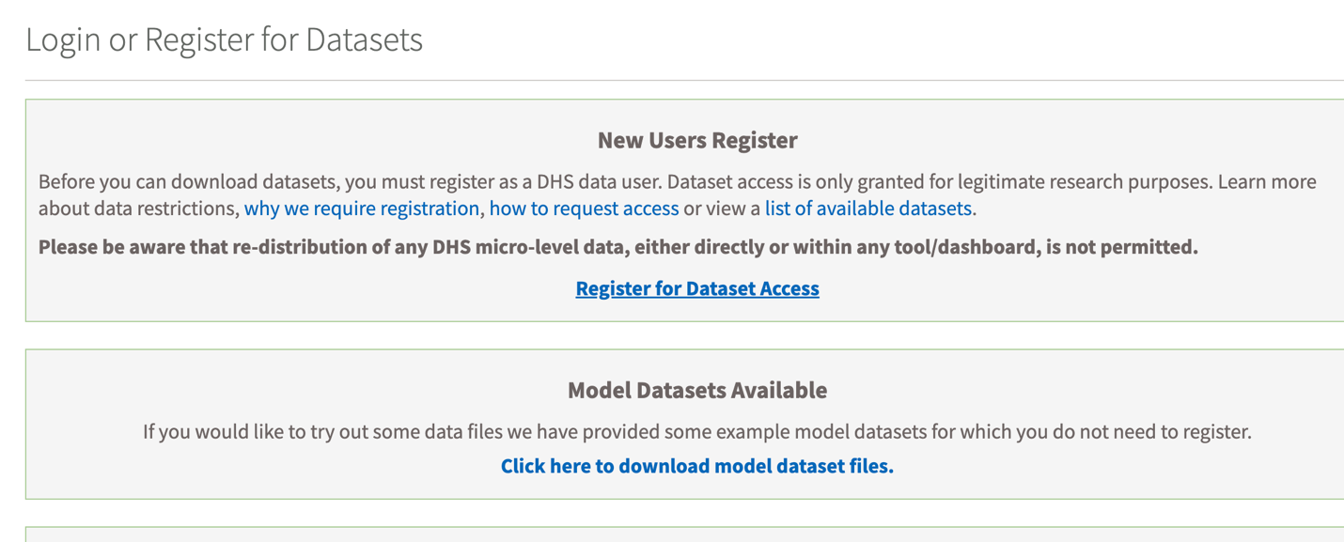
You have to justify the usage for requesting the data access. Here is a sample text to use:
This access is requested for data replication process for accepted paper on [TITLE] by [AUTHORS]. The analysis for the paper was carried out with DHS datasets under project title: [PROJECT TITLE].
In this project, the authors had requested the access for the following tasks:
[ORIGINAL ABSTRACT]
As the paper has been completed and accepted for publication by the [Journal], we are requesting access to check the data analysis process using replication codes submitted by the authors of the paper before publishing the paper. The access shall be used only for academic research purposes.
Once you are registered for data access, use the following selections in the DHS data downloading process to download the relevant data pertaining to this specific project:
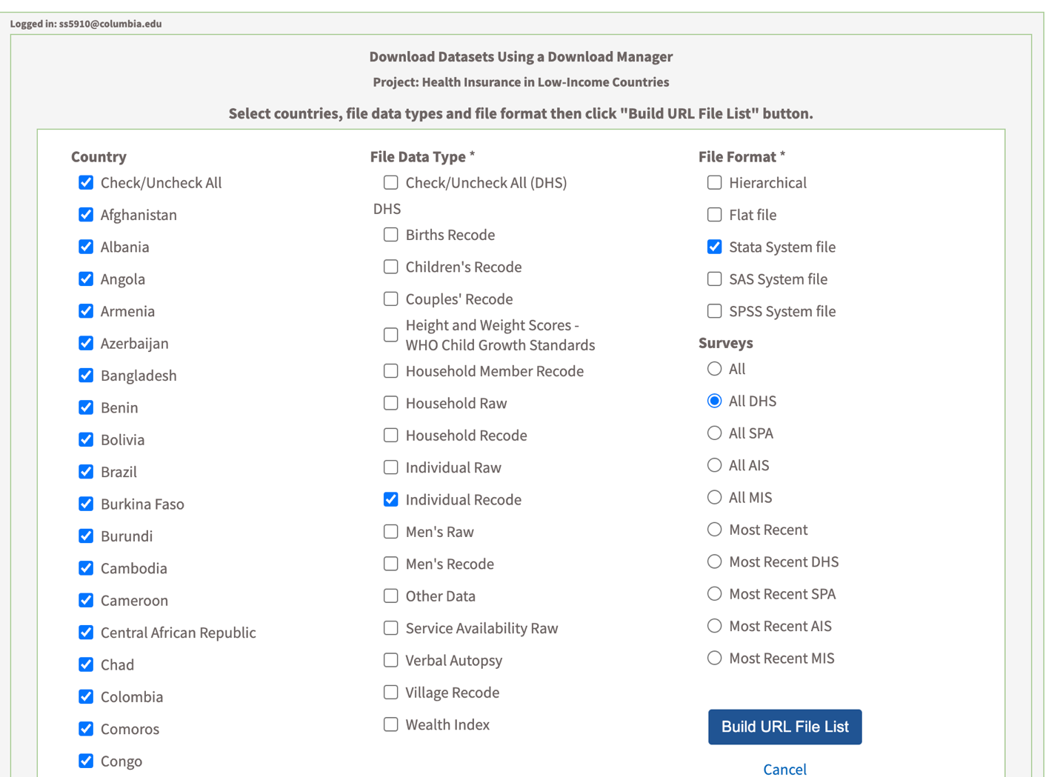

Click on the ‘Build URL File List’ button and wait a few minutes. The link to download the data will show up at the top like shown below:
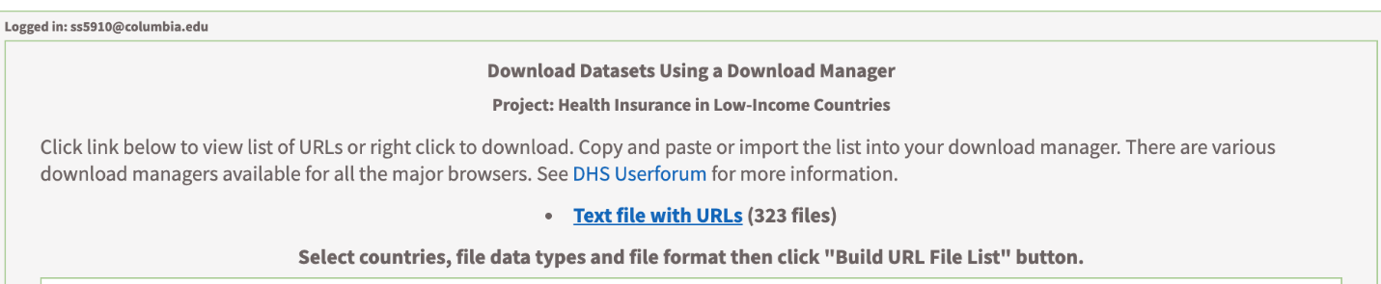
Click on the ‘Text file with URLs’ then you will see a list of URLs: 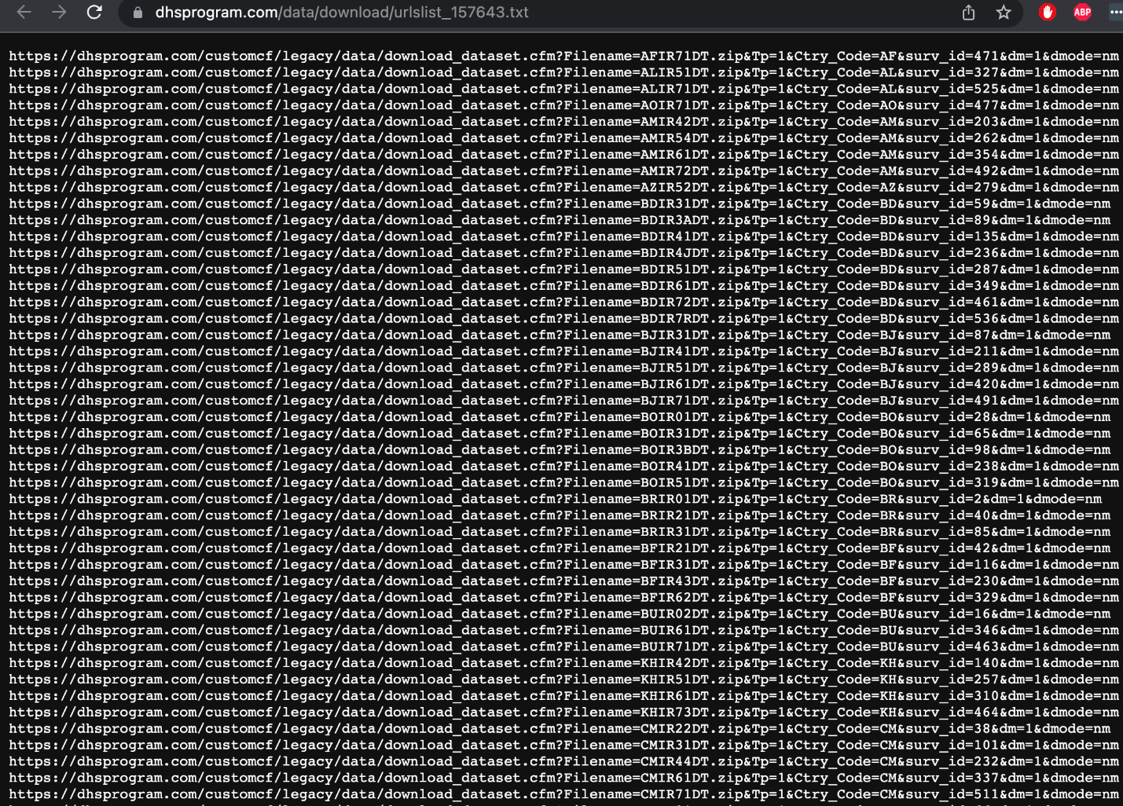
Copy and paste or import the list into your download manager. The Research Analyst for this project used ‘Simple Mass Downloader’. Here are the instructions on how this setup works:
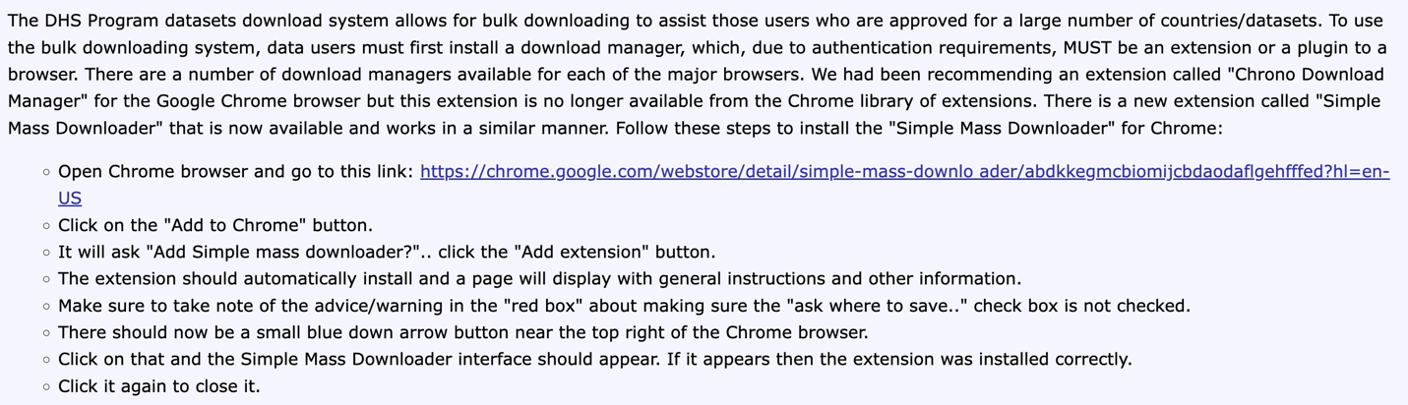
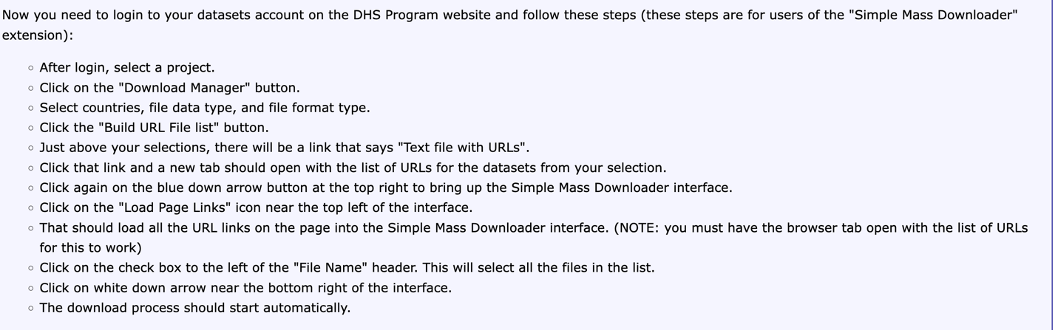
Here is a sample image on how the chrome extension will look like and how to operate the mass downloader:
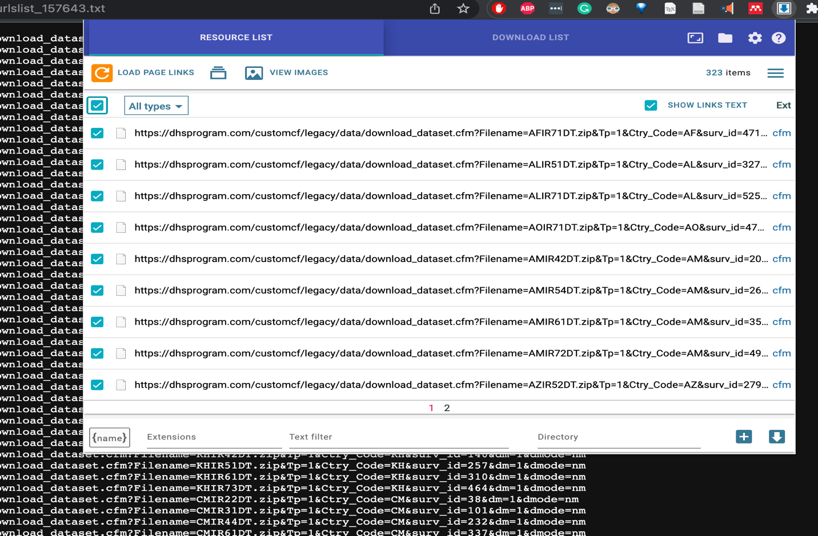
After clicking the download button, each country level zipfile will start downloading. These need to be added to the raw dataset folder path here: [YOUR REPLICATION FOLDER]
For more information see here: https://userforum.dhsprogram.com/index.php?t=msg&th=5246&start=0&S=4a22c1574b54935d933d662d79e0eaf2
After downloading the zipfiles check the following information:
- [add checks here]

